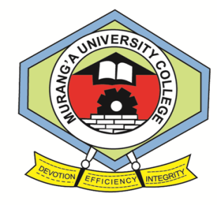

**MURANG’A UNIVERSITY COLLEGE**

***(A constituent college of Jomo Kenyatta University of Agriculture and Technology)***

**UNIVERSITY EXAMINATIONS 2013/2014**

**YEAR ONE SEMESTER I EXAMINATION FOR THE DIPLOMA IN INFORMATION TECHNOLOGY**

**SCI 1103: DATABASE SYSTEMS**

**COURSE: DIT TIME: 2HRS**

**DAY/TIME: Friday 8:30am-10:30 am DATE: 22nd August 2014**

**INSTRUCTIONS: *Answer question one and any other two questions***

**Question One (30 marks)**

1. Explain three phases of database design (6 marks)
2. Explain any four database objects found in Ms access (4 marks)
3. Define the following terms as they relate to relational databases (8 marks)
4. Database
5. Relation
6. Tuple
7. Super key
8. Explain the essence of defining input masks (2 marks)
9. Describe any three data types supported by MS Access (6 marks)
10. Outline the steps to follow to filter a table in Ms access (4 marks)

**Question Two (20 marks)**

1. State and describe five components of the database management system environment. (10marks)
2. Outline the procedure for defining a relationship in Ms Acess 2007/2010 (8marks)
3. Describe the essence of enforcing referential integrity when defining relationships

(2 marks)

**Question Three(20 marks)**

1. Discuss the three-tier database management system architecture describing four advantages it offers over the two-tier architecture (10 marks)
2. Wamagoro enterprises, your client wish to start using queries in displaying records from multiple tables and they have called you for help. Outline the procedure for creating a query that uses multiple tables in Ms Access 2007/2010 (8 marks)
3. Define a query (2 marks)

**Question Four (20 marks)**

1. Describe five functions that should be provided by a modern full scale multi-user DBMS (10 marks)
2. Describe any four properties of relational tables (8 marks)
3. Describe the essence of reports in database management systems (2 marks)